DEVELOPMENT OF A HYPERLOCAL ON-DEMAND PRODUCT DELIVERY & E-COMMERCE SERVICES USING MERN

A PROJECT REPORT

in partial fulfilment for the award of the degree

of
BACHELOR OF TECHNOLOGY IN

COMPUTER SCIENCE AND ENGINEERING

Under the Guidance of

PROF. SOMEN MONDAL

Project Carried Out At

COOCH BEHAR GOVERNMENT ENGINEERING COLLEGE
Maulana Abul Kalam Azad University of Technology

Submitted By

AYUSH GUPTA (Roll No: 34900118057) KHOKAN PAUL (Roll No: 34900119035)
KAZI MEHEBUB RAHAMAN (Roll No: 34900118049)
SHUBHAM BOSE ( Roll No: 34900118025..)


DEPARTMENT OF COMPUTER SCIENCE AND ENGINEERING

COOCH BEHAR GOVERNMENT ENGINEERING COLLEGE
(Note: All entries of the proforma of approval should be filled up with appropriate and complete information. Incomplete proforma of approval in any respect will be summarily rejected.)

- Title of the Project: DEVELOPMENT OF A HYPERLOCAL ON-DEMAND PRODUCT DELIVERY & E-COMMERCE SERVICES USING MERN
- Project Members: Ayush Gupta, Khokan Paul, Kazi Mehebub Rahaman, Shubham Bose
- Name and Address of the Guide: Prof. Somen Mondal
(Assistant Professor) Cooch Behar Government Engineering College
- Educational Qualification of the Guide: B.Tech, M.Tech

DECLARATION

We hereby declare that the project work being presented in the project proposal entitled “DEVELOPMENT OF A HYPERLOCAL ON-DEMAND PRODUCT DELIVERY & E-COMMERCE SERVICES USING MERN” in partial fulfilment of the requirements for the award of the degree of BACHELOR OF TECHNOLOGY IN COMPUTER SCIENCE AND ENGINEERING at COOCH BEHAR GOVERNMENT ENGINEERING COLLEGE, COOCH BEHAR, WEST BENGAL, is an authentic work being carried out under the guidance of MR. SOMEN MONDAL. The matter embodied in this project work has not been submitted elsewhere for the award of any degree of our knowledge and belief.

Name of the Students

- Ayush Gupta
- Khokan Paul
- Kazi Mehebub Rahaman
- Shubham Bose

ACKNOWLEDGEMENT

Success of any project depends largely on the encouragement and guidelines of many others. We take this sincere opportunity to express our gratitude to the people who have been instrumental in the successful development of this project work.

Our heartfelt thanks to the respective Departmental HOD of our Department for providing us the opportunity to develop the project.

We would like to show our greatest appreciation to Prof. Somen Mondal, Project Mentor and Senior Faculty Member at Cooch Behar Government Engineering College, Cooch Behar. We always feel motivated and encouraged every time by his valuable advice and constant inspiration; without his encouragement and guidance this project would not have materialized.

Words are inadequate in offering our thanks to the other trainees, project assistants and other members at Cooch Behar Government Engineering College for their encouragement and cooperation in carrying out this project work. The guidance and support received from all the members and who are contributing to this project, is vital for the success of this project
Table of Contents
Table of Contents

- INTRODUCTION
- BACKGROUND
- PURPOSE
- SCOPE

In-scope Functionalities
    - Customer View
      - Login and Registration
      - Account
      - Home
      - Search
      - My Order
      - Payment
      - Cart
      - Product Description
      - Review and Ratings
      - Notifications
      - Contact
    - Shopkeeper View
      - Login and Registration
      - Update price panel
      - Recent and Active Orders
      - Account
      - Add items
      - Payments
      - Order History
      - Contact
      - Notifications
      - Add Offers
      - Shop view
- OVERALL DESCRIPTION
  - Product Perspective
    - Web Ordering System Module
    - Order Management system module
    - Environment and Technology Requirement
    - Order Retrieval System /module
- ASSUMPTIONS
- WORKFLOW DIAGRAM
  - Login & Registration Process Workflow Diagram
  - Order Placement Process Workflow Diagram
- FUNCTIONAL REQUIREMENTS
- UML ANALYSIS MODEL
  - Use case
  - Use case for Customer
  - Use case for Restaurant
- NON-FUNCTIONAL REQUIREMENTS
- REFERENCE

- INTRODUCTION

With the increase in internet connectivity and digitization people are more rushing into online mode of activities whether it is shopping, payment, social media or other online activities, Nowadays people are also more giving values to their time and money and are switching more towards the online mode for shopping purpose and this leads to the open for a vast market for e-commerce , but due to this people like the retailers were the main sufferer but taking consideration for all we have decided to make an application based on hyperlocal on-demand business model which would be beneficial for both shopkeeper as well as the consumer, our application would bridge the gap between the two, like Zomato and Swiggy for the restaurant and foods we brought a different concept for connecting local groceries store to the consumer directly through our application.

- BACKGROUND

The emergence of the on-demand economy has revolutionized the traditional business models at an advanced rate in the last few years. From hailing a cab to getting a spa massage, buying groceries to ordering food, purchasing medicine to renting furniture, the on-demand apps have made our life easier than before. Smartphones have become the game-changer for the on-demand delivery business models
A report from Harvard Business Review in 2016 pointed out that the on-demand economy is attracting more than 22.4 million consumers annually and $57.6 billion in spending. Moreover, the report says 49% of the users of on-demand services are millennials. The number is growing at an exponential rate globally and is expected to skyrocket in the coming years.
The term ‘hyperlocal’ refers to ‘a small area’ or ‘a very specific demography.’ Hyperlocal on-demand delivery model is defined as a business model in which the service provider acquires requested product(s) locally and deliver the same to the customer in the same geographical area.
There are many business model running with similar hyperlocal on-demand business model are UberEATS, Zomato, BigBasket, Postmates etc.

- PURPOSE

Our Application will provide a B2C business model and will detect all the retailers shops connected to our application under certain radius of distance from the user location, and also the user will get the list of the prices offered by the different retailer, so they could compare the quality and price and get the best product at best price and due to the short distance they would get it in a very short period of time, this would also help the retailers to get the customer also help the user to get any emergency needs or supplies at anywhere without going out to visit the store, this will be more beneficial for the people who are living in flats or to the people were there are not more grocery store in the locality.

- SCOPE
  - In scope functionalities

    - Customer view
      - Login and Registration
If User is a New User, then He/she can register on the System. For registration user needs to fill the registration form (Name, Date of Birth, Gender, Email Id, Mobile Number, Password) after this System send OTP and Verification Mail to register Mobile number and Email Id to activate the account
After successfully registration User can login into the system by registered Mobile number and password OR Registered Email Id and Password.
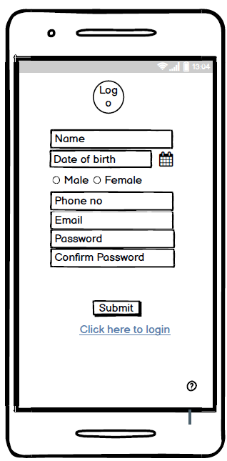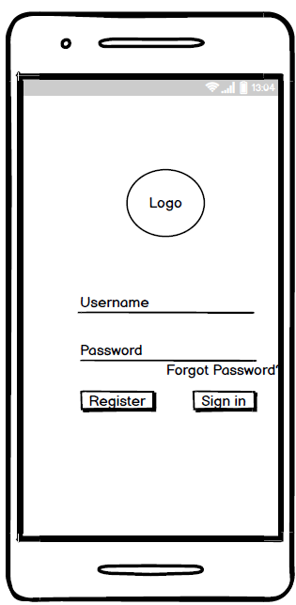

      - Account
From Account section user can manage all the details of them like: Address, Phone Number, Pin code, Email Id and many more

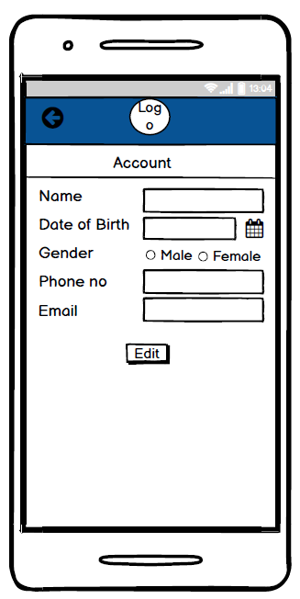

      - Home
Home is the Dynamic page that shows Offers, Categories, products and widgets. By clicking on any function of the home page User can navigate to that page or function.
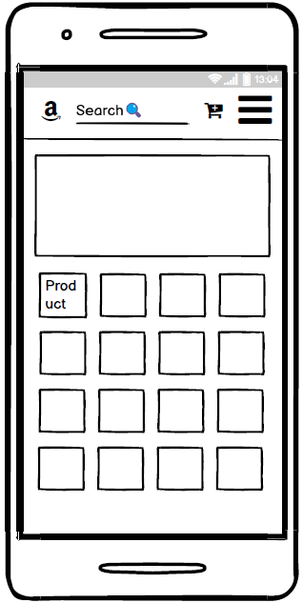

      - Search
Search is the function from that user can search any product. User need to write any keyword or name of products and system show related products and services according to that keyword.The search bar is in the top of the navigation


      - My order
My Order is the one page where user can get all the Food details current as well as previous orders.

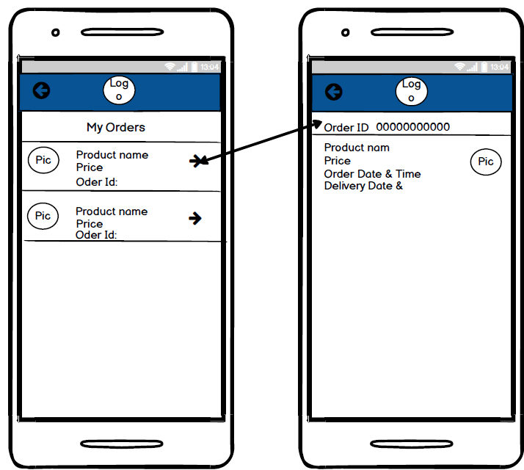

      - Payment
After buying of the product user need to pay the amount online OR Cash on Delivery. If User want to pay online then they have different options like Credit Card, Debit Card, Wallets, Net Banking.

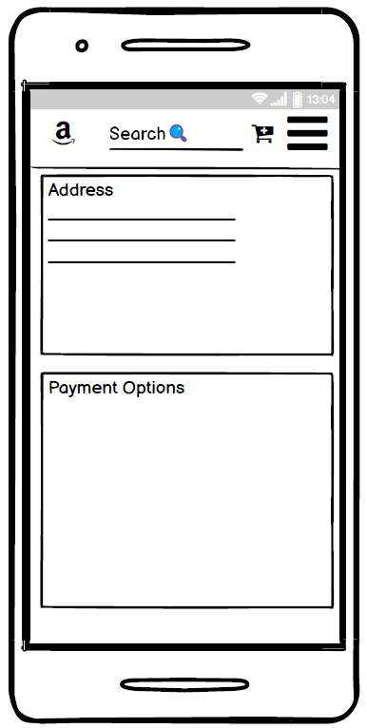

      - Cart
User can add different products to their cart and order all at once

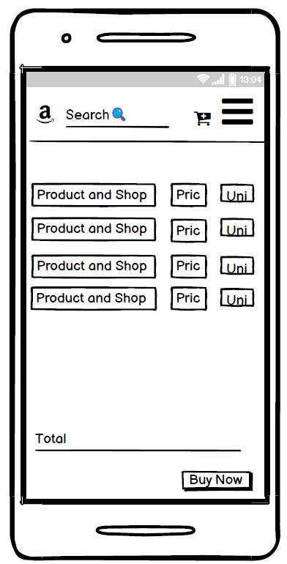
Cart

      - Product Description
In Product description page the customer could view the latest price and photos of the product and also the ratings of different store who is selling that product

      - Review and Ratings
User could give review to the store on the basis of their experience and quality of the product purchase, They could also rate the store they like, this could help others for future reference like by this they could know the quality and service the store provides to their customer

      - Notification
User would get the notification of the offers and also about the delivery of purchase

      - Contact
User can get in touch with customer care executive if user have any query or any question. User could also give additional feedback for the quality of product to their respective stores

    - Shopkeeper View
      - Login and Registration
If Shop owner is a New User, then He/she can register on the System. For registration user needs to fill the registration form (Shop Name, Owner Name, Date of Birth, Gender, Address, Email Id, Mobile Number, Password) after this System send OTP and Verification Mail to register Mobile number and Email Id to activate the account
After successfully registration Shop owner can login into the system by registered Mobile number and password OR Registered Email Id and Password.
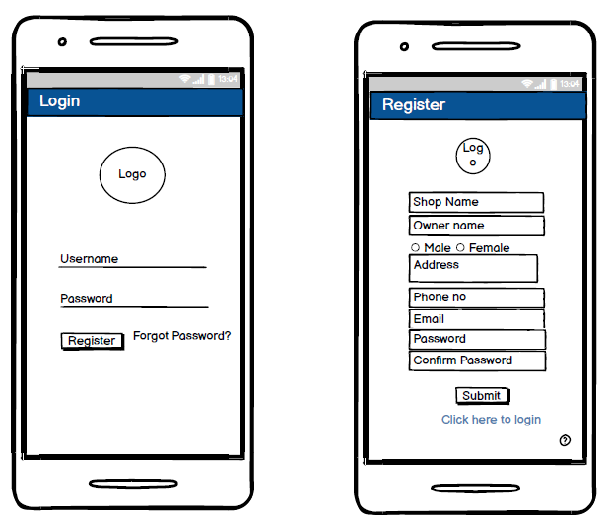

      - Update Price Panel
By this section the shop owner could update the price of the product he sells in his shop, whenever the rice will rise or fall he/she would update the price and the change would be reflected in the database and user would see the updated value

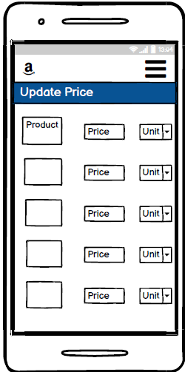

      - Recent and Active orders
Here shopkeeper would be able to view the recent orders of last 3 days and all the active orders they need to deliver at that moment

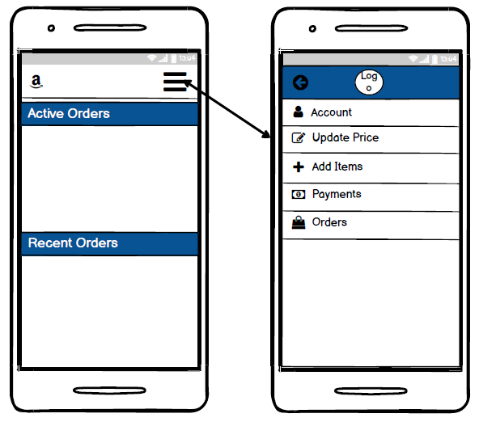

      - Account
In Account section the shop owner could edit their shop details modify the changes for better reach
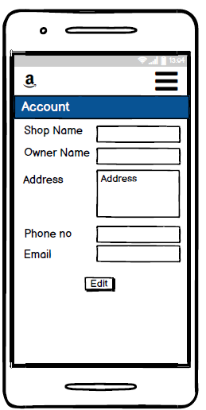

      - Add Items
Here, the shop owner could add more items to their dashboard, so that they could offer more to their customers
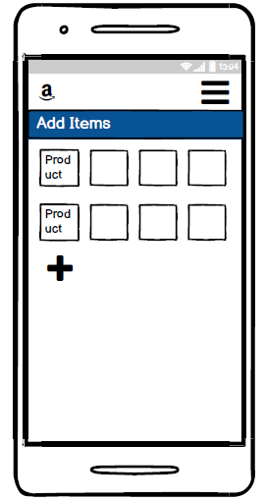

      - Payments
In payments section they could trace the payment status of their orders and could check the records of payment received from the customer on delivery of their products
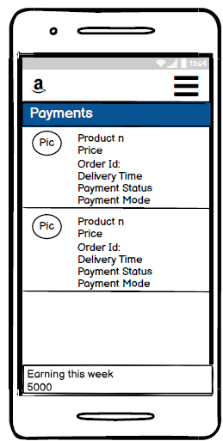

      - Order History
Here the shop owner could view all the history of purchases of last 30 days from his store
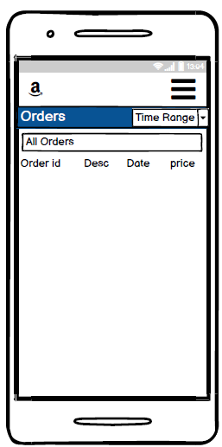

      - Contact
By using these the shop owner could contact the support and administrative for any queries and issues they face while using the app

      - Add Offers
By this section shop owner could provide offers on their product or on total purchase of their shop to the customers which will be displayed on the dashboard of the user

Store View
From here the user could view how their store look likes in the user device and if they want t o do some additional changes they can get the option of edit in different sections

- Overall Description
The following section presents an overall description of the subject ShopHome. In particular, the producthas been put into perspective through a detailed assessment of the system, user, hardware,
software and communication interfaces, memory considerations, operational modes and site
adaptation requirements. Further, characteristics of the system’s end-users are discussed along with
the identified system constraints and assumptions. To conclude the section, an apportioning of
requirements have been outlined
  - Product Perspective
The online grocery items ordering applications would have the following basic functions
- Web Ordering System Module
This module provides the functionality for customers to place their order and supply necessary
details. Users of the system, namely restaurant customers, must be provided the following functionality:
∙ Create an account.
∙ Manage their account.
∙ Log in to the system.
∙ Navigate the grocery items
∙ Select the item and store for ordering
∙ Add an item to their current order.
∙ Review their current order.
∙ Remove an item/remove all items from their current order.
∙ Provide payment and address details.
∙ Place an order.
∙ Receive confirmation in the form of an order number.
∙ View order placed.
- Menu Management System Module
This module provides functionality for the power user-Administrator only(Shop-owner). It will not be availableto any other users of the system like Customers.Using a graphical interface, it will allow an Admin to manage the menu that is displayed to users of theweb ordering system:
∙ Add /update/delete items to/from the list.
∙ Update price for a given item.
∙ Update additional information (description, photo, etc.) for a given item.
Before customers can use this system, functionality provided by this component will have to
be configured first. Once the initial configuration is done, this will be the least likely used component as menu updates are mostly seasonal and do not occur frequently

- Order Retrieval System Module
This is the simplest module out of all 3 modules. It is designed to be used only by restaurant
employees, and provides the following functions:
∙ Retrieve new orders from the database.
∙ Display the orders in an easily readable, graphical way.

- Environment and Technology requirement.
∙ The application will be fully workable webAndroid/iOS. Theminimal required hardware resources can be assumed as the same as for using for theProject we have.
∙ Webpages are required to properly fit on mobile devices, working on iOS and
Android platforms.
∙ Application must be implemented in MERN (Web), React Native(Android).
∙ MongoDB will be used as a database.

- Assumptions
- L
- List of all the shops which is registered through our application will be provided in the application for the user.
- All the product details and image would be uploaded by the merchants.
- All the ratings and reviews for quality and service would be given by the customers and would be shown in the application.
- Terms and conditions will be provided by the legal team.
- Discounts and offers would be provided by the shop owners (merchants).
- Feedback details options would be provided to the customer for any feedback or queries regarding the product

- WORKFLOW DIAGRAM
  - Login & Registration Process Workflow Diagram
This is a workflow diagram of how the login and registration process will work on the website
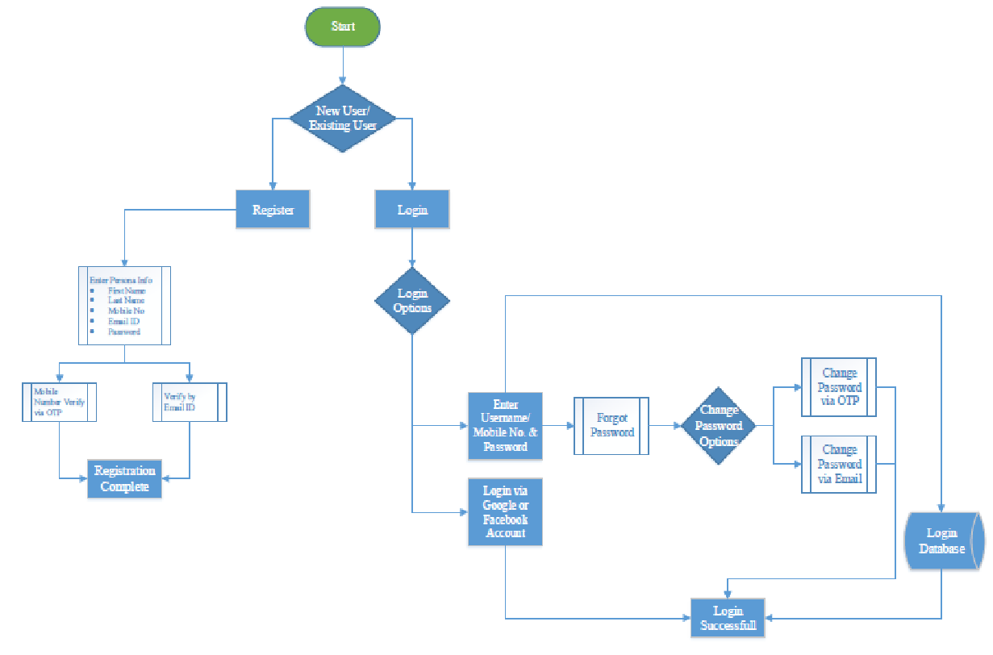

  - Order Placement Process Workflow Diagram
This is a complete workflow diagram for the orders taking place from selecting an item to the order confirmation

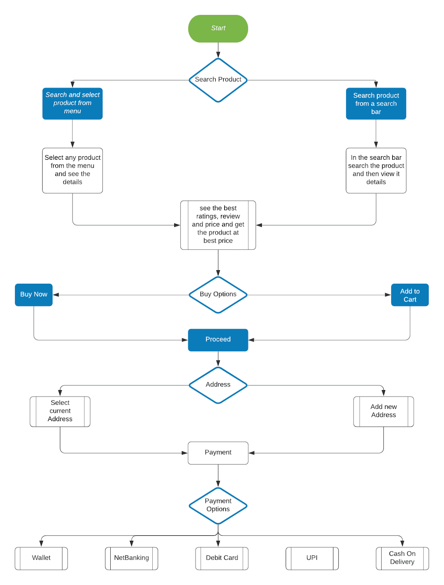
Order Placed

- FUNCTIONAL REQUIREMENTS

This subsection provides the functional requirements for our subject Application.Initially, general requirements that pertain to thewhole system are given. Where possible, subsequent requirements havebeen demarcated based on their relevance to the users of the system,that is, Customers, Shop Owners, and Admin.

Req ID | Requirement Description
R1 | Customer Shall be able to login or skip from registration to enter the menu dashboard
R2 | Customer shall be able to view nearby retail stores (Specified Distance)
R3 | Customers shall be able to choose their favorite retail store they wish to order items
R4 | Customer shall be able to order items and add to cart
R5 | Customers shall be able to view menu and search their desired product
R6 | Customers shall be able to remove orders from cart
R7 | Customers shall be able to engage bill mode to finalize payment through their engaged menu by cash
R8 | Customers shall be able to navigate between menu and can add items to cart
R9 | When in billing mode, app shall display a representation of a bankcard payment through a payment gateway for each customer
R10 | Customers could able to apply offers they get on the product by the retail store
R11 | Customer shall able to give rating for product quality and services
R12 | Retailers shall be able to (CREATE, READ, UPDATE, DELETE) items from menu
R13 | Retailers shall be able to view the orders which has been ordered by customers
R14 | Retailers shall be able to receive orders from customers
R15 | Retailers shall be able to view the payment
R16 | Retailers shall be able to give offers
R17 | Admin shall able to manage users
R18 | Admin shall able to CRUD items for restaurant
R19 | Admin shall able to display top rated retail stores
R20 | Admin shall to add promo code/offers
R21 | Retailer could able to see the monthly and weekly sales from the outlet
R22 | Customer could fetch the sorted price of products with store name on the product description page to get best quality at effective price
R23 | Retailers shall entertain the feedback and reviews by the customers to improve their service experience
R24 | Rating shall not be given to any retail store without any purchase

- UML ANALYSIS MODEL

This subsection extends upon the functional requirements given through the presentation of detailed use cases. To facilitate an unambiguous and clear view of how the end-users interact with the Shop home, the actors (endusers) involved in the use cases, a use case diagram and detailed use case descriptions are provided. The use cases that find representation are Log In, Log Out, Accept Order, Deliver Item, Process Bankcard Payment, Process Cash Payment, Abort Account, Issue Refund, Place Order, Pay Bill, Accept/Reject Item and Indicate Item Ready.

  - Use case

There are Two panel in the Shop home are Customer, Shopkeeper.

Login

Customer
Select Item

Add to Cart

View Total & Amount

Delivery Address

Confirm & Payment

Rating

Logout

Shopkeeper
View Cart

  - Use case for Shopkeeper

Shopkeeper
Accept Order
User Details
Delivery Details
Order Arrived
Order Pickup
Payment From User
Transit Product

- NON-FUNCTIONAL REQUIREMENTS
Functional requirements define what a system is supposed to do and non-functional requirements define how a system is supposed to be. A non-functional requirement is often called Quality attributes of a system. They specify criteria that judge the operation of a system, rather than specific behaviors, for example: “Modified data in a database should be updated for all users accessing it within 2 seconds.”

9.1 Some typical non-functional requirements are:
- Security
It is important to specify the level of security that should be met.
- Privacy
Meeting basic requirements for GDPR.
- Scalability and performance
Ensuring that the system can scale to meet expected traffic and order volume at normal and peak times.
- Speed of web services
Defining how long web services will take to provide a response.
- Accessibility
Ensuring that the platform meets the basic accessibility standards throughout.
- Documentation
Ensuring that the platform is sufficiently documented.
- Quality
Even the best e-commerce platforms can be used badly so you should insist that code is developed to a good quality standard.
- Extensibility
Ensuring that the platform is extended in such a way to make future development feasible.
- Data integrity and retention
Defining how long data should be stored and how the integrity of data is maintained.
- Testing
Defining how unit testing will be built into the solution.
- Compatibility
Ensuring that the platform can be easily integrated with 3rd party systems.
- Search
Defining how quickly the system will return search results.
- Availability
Defining the agreed uptime of the platform under normal conditions.
- Infrastructure
Defining the infrastructure performance thresholds (CPU and memory usage).

- REFERENCES
- We took reference from other B2B and B2C model websites like Grofers , swiggy, zomato,etc.
- Balsamiq. Rapid, Effective and Fun Wireframing Software | Balsamiq. Wireframes are made using balsamiq
- Took reference from different B2C model websites and applications
- Workflow diagrams are made using Lucidchart diagrams
- Consulted with mentors for looking various aspect
- Discussed with friends to get some different ideas
- Took local surveyed from retail stores and get feedback to get better experience and deeply understand the usage and demand for the application
- Surveyed from people living in apartments and flats for better understanding their requirements
- UML analysis models and user case diagrams are made using Microsoft word
- For technologies we are using is a MERN stack for web based and later we will implement this on app based using react native
- For database part we are using MongoDB https://www.mongodb.com/
- For the front-end we are going to use React JS https://reactjs.org/
- For back end we are using Express Js https://expressjs.com/ and Node JS https://nodenejs.org/en/
- We took the reference from the different play store application engaged in such type of business models
- We gone through several blogs and websites to study different business models
- the idea of HYPERLOCAL ON-DEMAND PRODUCT DELIVERY SERVICES model came from the ease of how website like swiggy and zomato deliver the food within an hour
- On seen problems of upscaling local business and solving an issue of people living in apartment we decided to build this website
- https://mobisoftinfotech.com/resources/blog/hyperlocal-on-demand-delivery-model-effects-and-benefits/ hyperlocal on demand business model

